Лабораторная работа № 11

Факториал

Написать программу вычисления факториала.
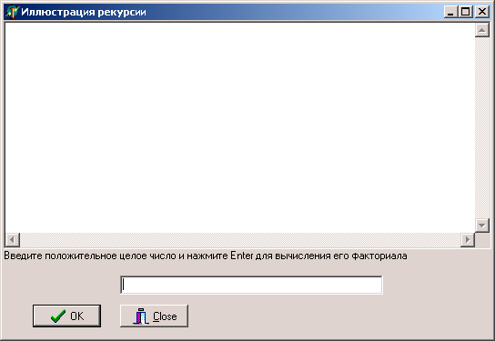
unit Unit1;
interface
uses
Windows, Messages, SysUtils, Variants, Classes, Graphics, Controls, Forms,
Dialogs, StdCtrls, Buttons, ExtCtrls;
type
TfmExample = class(TForm)
Panel1: TPanel;
bbRun: TBitBtn;
bbCancel: TBitBtn;
edInput: TEdit;
mmOutput: TMemo;
lbOutput: TLabel;
procedure bbRunClick(Sender: TObject);
procedure FormActivate(Sender: TObject);
private
{ Private declarations }
public
{ Public declarations }
end;
var
fmExample: TfmExample;
implementation
{$R *.dfm}
procedure TfmExample.bbRunClick(Sender: TObject);
Function Factorial(N: Word): Extended;
begin
if N = 0 then
Result := 1
else
Result := N * Factorial(N-1)
end; // Factorial
var
N: Integer;
begin
try
N := StrToInt(Trim(edInput.Text));
except
Exit;
end;
mmOutput.Lines.Add(edInput.Text+'! = '+FloatToStr(Factorial(N)))
end;
procedure TfmExample.FormActivate(Sender: TObject);
begin
edInput.SetFocus
end;
end.
Программа:

program Factorial;

uses
Forms,
Unit1 in 'Unit1.pas' {fmExample};

{$R *.res}

begin
Application.Initialize;
Application.CreateForm(TfmExample, fmExample);
Application.Run;
end.

